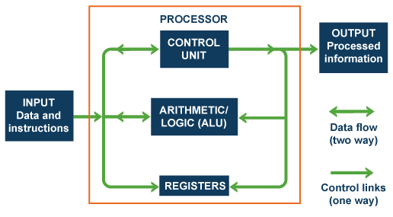In **computer** engineering, **computer architecture** is a set of rules and methods that describe the functionality, organization, and implementation of **computer** systems. Some definitions of **architecture** define it as describing the capabilities and programming model of a **computer** but not a particular implementation.

Computer Structure

A data bus is a system within a computer or device, consisting of a connector or set of wires, that provides transportation for data. Different kinds of data buses have evolved along with personal computers and other pieces of hardware

An address bus is a computer bus architecture used to transfer data between devices that are identified by the hardware address of the physical memory (the physical address), which is stored in the form of binary numbers to enable the data bus to access memory storage.

The address bus is used by the CPU or a direct memory access (DMA) enabled device to locate the physical address to communicate read/write commands. All address busses are read and written by the CPU or DMA in the form of bits.

Machine code (MC) is the executable instruction code provided by all running computer system programs and applications. MC language is a low-level code interpreted and converted from high-level source code and understood only by the machine. Machine code is transported to the system processor when a specific task, application or program executes even the smallest process.

Machine code is also known as machine language (ML).